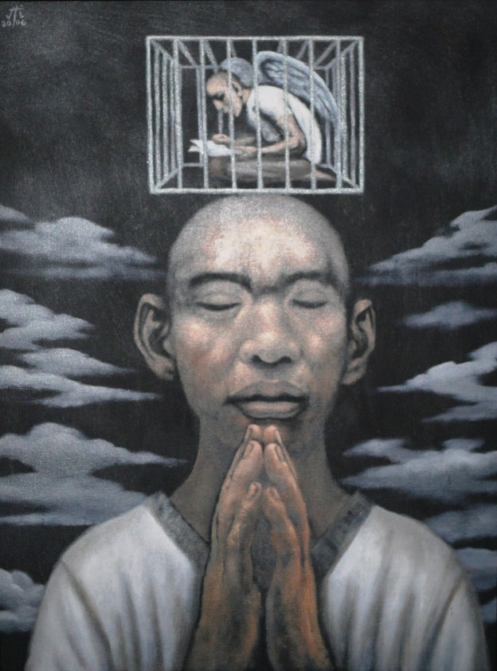

*Mark Justiniani*

“Hawla”, 2006.

Oil on board.

22” X 28”

“Hawla” is Tagalog for “Caged”